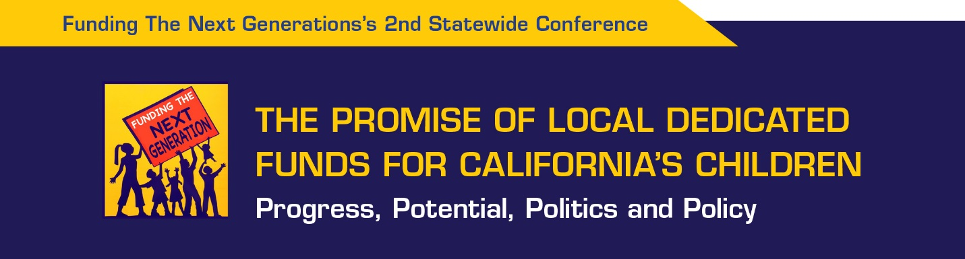

Welcome
Lessons Learned – 9:00 – 9:30
Margaret Brodkin, Founder and Director of Funding the Next Generation
Review of progress and recommendations for future campaigns for Children’s Funds

Three Community Stories – 9:30 – 10:00
There are many ways to approach pursuing a dedicated funding stream for children. These are three examples currently underway.
Joelle Gallagher, Executive Director, COPE Family Center, County of Napa
Kimberly Aceves, Executive Director, RYSE Youth Center, Richmond, California
Jesse Ortiz, Yolo County Superintendent of Schools, Yolo County

Role of Elected Officials – 10:00 – 11:15
Elected officials have played a variety of roles in developing dedicated funding streams – from leaders, to behind-the-scenes supporters, to legislative champions.
MODERATOR: Dr. Anthony Iton, Senior Vice President for Healthy Communities, The California Endowment
City councilman Jay Schenirer, Sacramento
Supervisor Steve Kinsey, Marin County
Supervisor Shirlee Zane, Sonoma County
Supervisor Linda Seifert, Solano County
Supervisor Kathy Miller, San Joaquin County

Benefits of a Local Children’s Fund – 11:15 – Noon
Lieutenant Governor Gavin Newsom
Gavin Newsom has had more experience with a local Children’s Fund than any other elected official or chief executive in the country. His talk will be followed by a Question and Answer session.

BREAK – Box lunches will be available.

How Public Opinion Research Is Informing Our Strategies - 12:15 – 1:45
Celinda Lake, Lake Research Partners
Dave Metz, FM3 Research
The presentations will focus on current public opinion on children, youth and family issues heading into 2016, how polling can support work toward dedicated children’s funds, and the themes, messages and implications from the polling done over the past two years in California on funding children’s services.

Mini-plenary Sessions – 2:00 – 3:15
- Drafting a Measure – There are many considerations in drafting a measure. You will get information and advice from 4 experts with recent experience assisting campaigns.
Bradley Hertz, J.D., Sutton Law Firm – Overview of the basics of a ballot measure
Ed Harrington, Former Controller of San Francisco – Developing the fiscal strategy and language
Harry Berezin, J.D., Remcho Johansen and Purcell – Scope of considerations and potential challenges
Sara Kershnar, RYSE Youth Center – How to engage community partners in drafting a measure

- Running a Children’s Fund Campaign – A campaign for funding for services for children and youth has unique opportunities and unique challenges. This session will cover the timeline, messaging, endorsements, organizing the base, and countering opposition.
Nicole Derse, Co-founder and Principal of 50+1 Strategies
Commenters: Jill Wynns, Board of Directors, California School Board Assn., and Dave Metz, FM3

- Engaging Youth and Parents in a Ballot Measure Campaign – A key to success is engaging those most impacted by the measure. From San Francisco’s latest Children’s Fund campaign which expanded services up to age 24, to the experience of the fledgling campaign in Solano, the discussants will address what it takes to be successful.
Jose Luis Mejia, Director of Programs, Coleman Advocates for Children and Youth
Youth from RYSE - Anure McGee and Diana Ramirez, with Deanna Gao, Youth Organizer, RYSE
Parents from the Parent Leadership Training Institute in Solano – Lenesha Anderson, Bethany Smith, Van 0’Bryan II, Sylvia Robertson, with Alan Kerzin, Executive Director, Children’s Network of Solano County
Onward: Final comments and participant feedback – 3:15 – 3:30
What happens next? Hear from 2 dynamo campaign organizers, Kim Thomas, Funding the Next Generation Solano, and Christina Gilbert, San Joaquin Children’s Alliance, how they plan to move forward – and how Funding the Next Generation can help them and can help you, our conference participants. Facilitated by Margaret Brodkin.

Networking and reception – 3:30 – 4:00

THANK YOU to The California Endowment, the primary funder of this initiative, and to the Evelyn and Walter Haas, Jr. Fund, for supporting this conference. Previous funders have included Sierra Health Foundation, Rosenberg Foundation, San Francisco Foundation, Cowell Foundation. The San Franisco State Masters in Public Administration Program is providing volunteers.

Funding the Next Generation is a project of San Francisco State University, College of Health and Social Sciences.

